Assignment 14
Problem Statement:-Create an Elastic IP for an instance.
Step1:First we will create a instance. Select ubuntu, key pair, select all the check box in security.
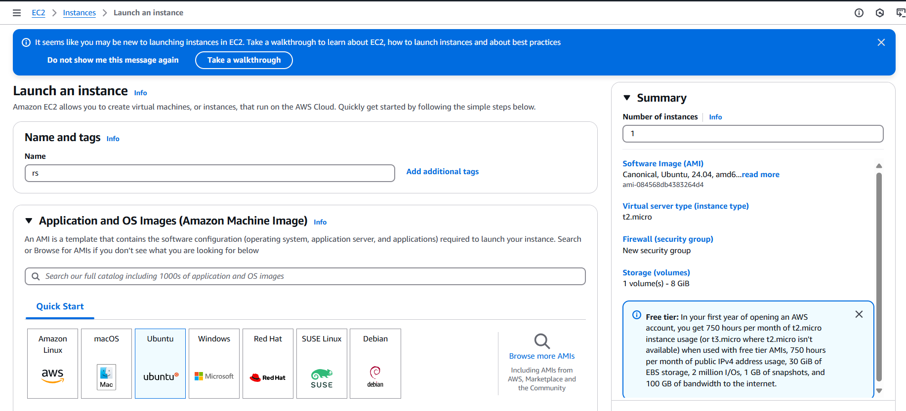
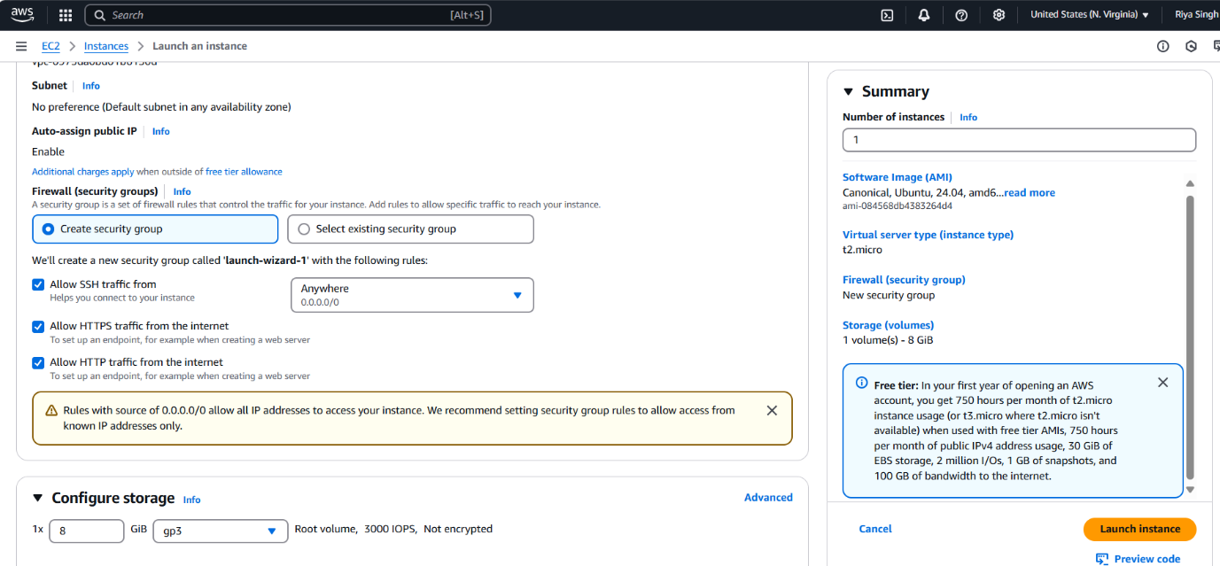
Step2:Now select instance and stop instance.After some time start instance. Note both pervious and now public IPv4 address.

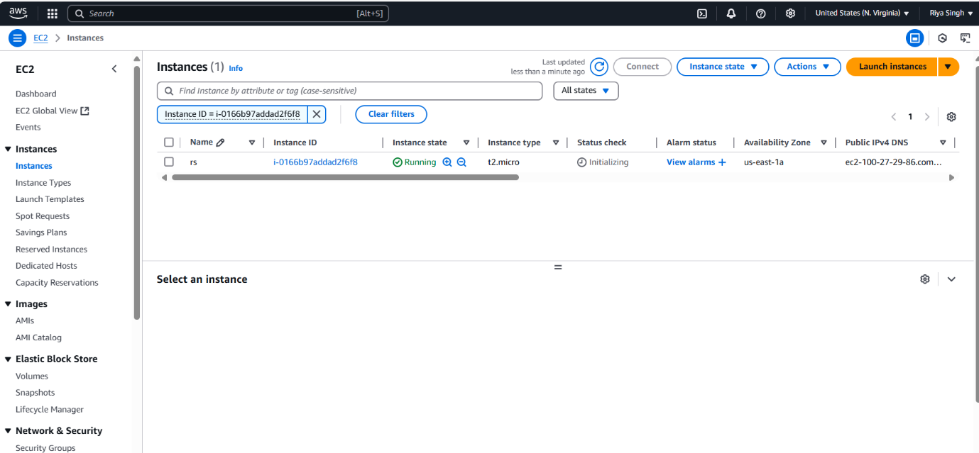
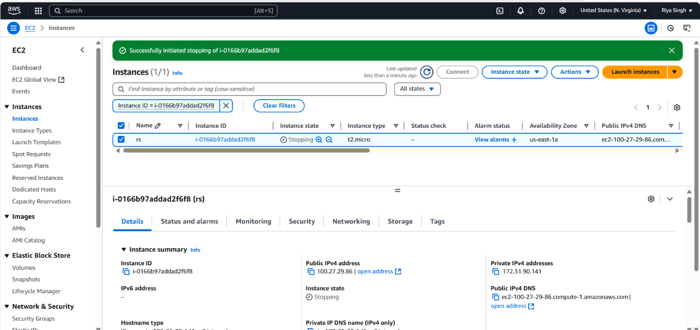
Step3:Go to Elastic IPs and allocate it.
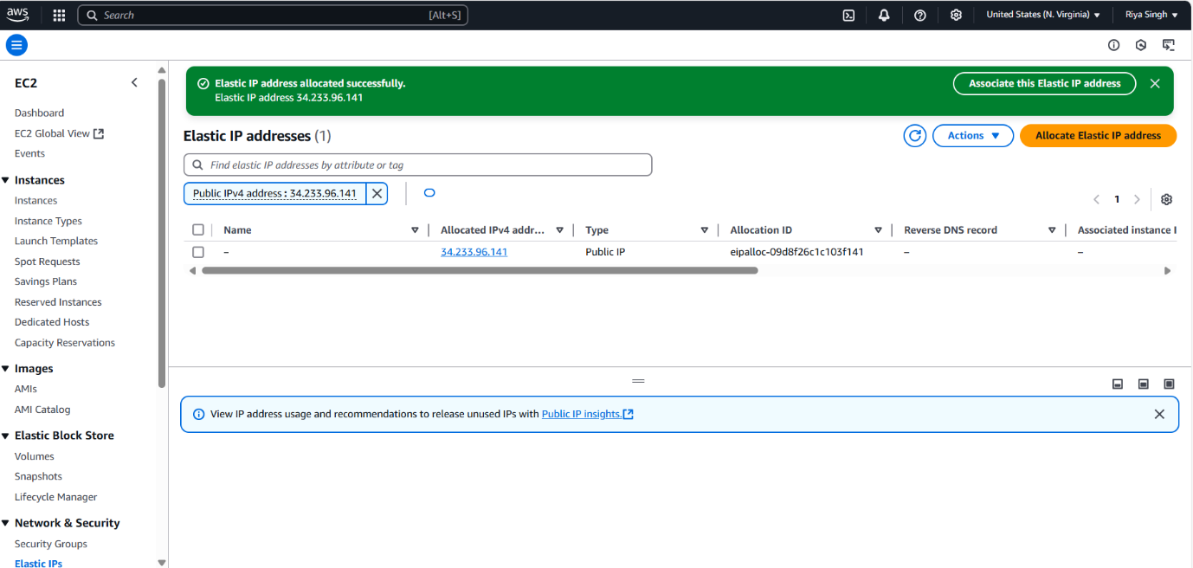

Step4:Now associate Elastic IP address, select resource type instances.
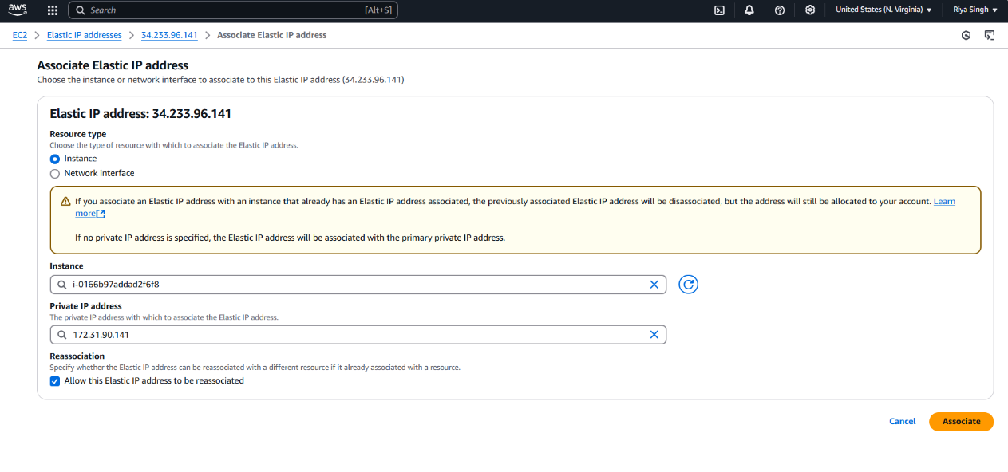
Step5:Again now stop and start the instance, no IPv4 address will be changed. (before stoping-3.216.220.105, after stopping- 3.216.220.105)
